**STUDENT HANDOUT HTML-CHAPTER1**

**HTML BASICS**

**About Workshop:**

In this workshop, we'll explore the fundamentals of creating a simple HTML webpage. HTML, or HyperText Markup Language, is the backbone of web development and is used to structure the content of web pages. In this handout, we'll dissect a basic HTML document and explain its various components. In this chapter, we are divided into five workshops, each of which illustrates how to effectively utilize these elements in your application.

The Scrum Master can divide the workshop among team members, and you can proceed to walk through the tasks assigned to you.

**WORKSHOP1:**

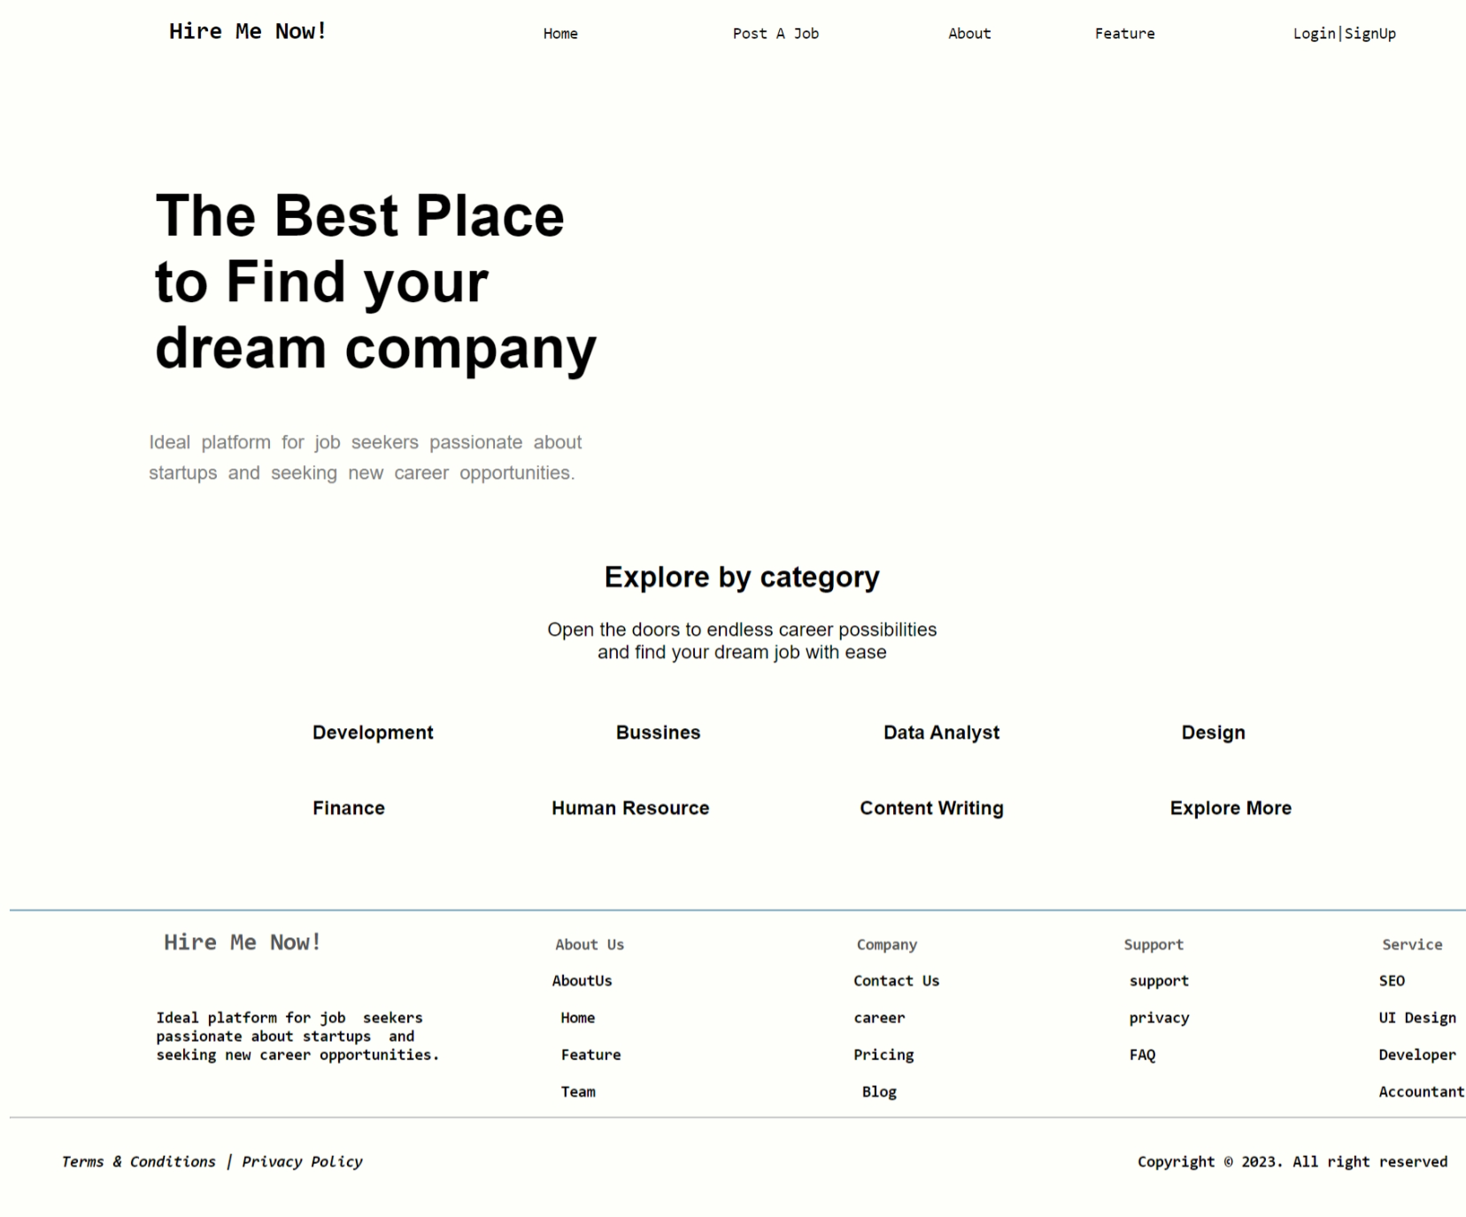

**Expected output:-**



During this workshop, we will be constructing a page related to the Job Portal System. On this page, you will gain a better understanding of creating the basic structure of an HTML document, utilizing essential HTML elements and attributes, and formatting text and structuring content within an HTML page. To complete this webpage, you should add a footer section using basic HTML elements and attributes. The footer should include information such as 'Contact Us,' 'Privacy Policy,' and any other relevant details, using appropriate HTML tags like <p>, and <a> for links. Additionally, make sure to utilize attributes like 'href' and 'target' to ensure the links are functional.

**WORKSHOP2:**

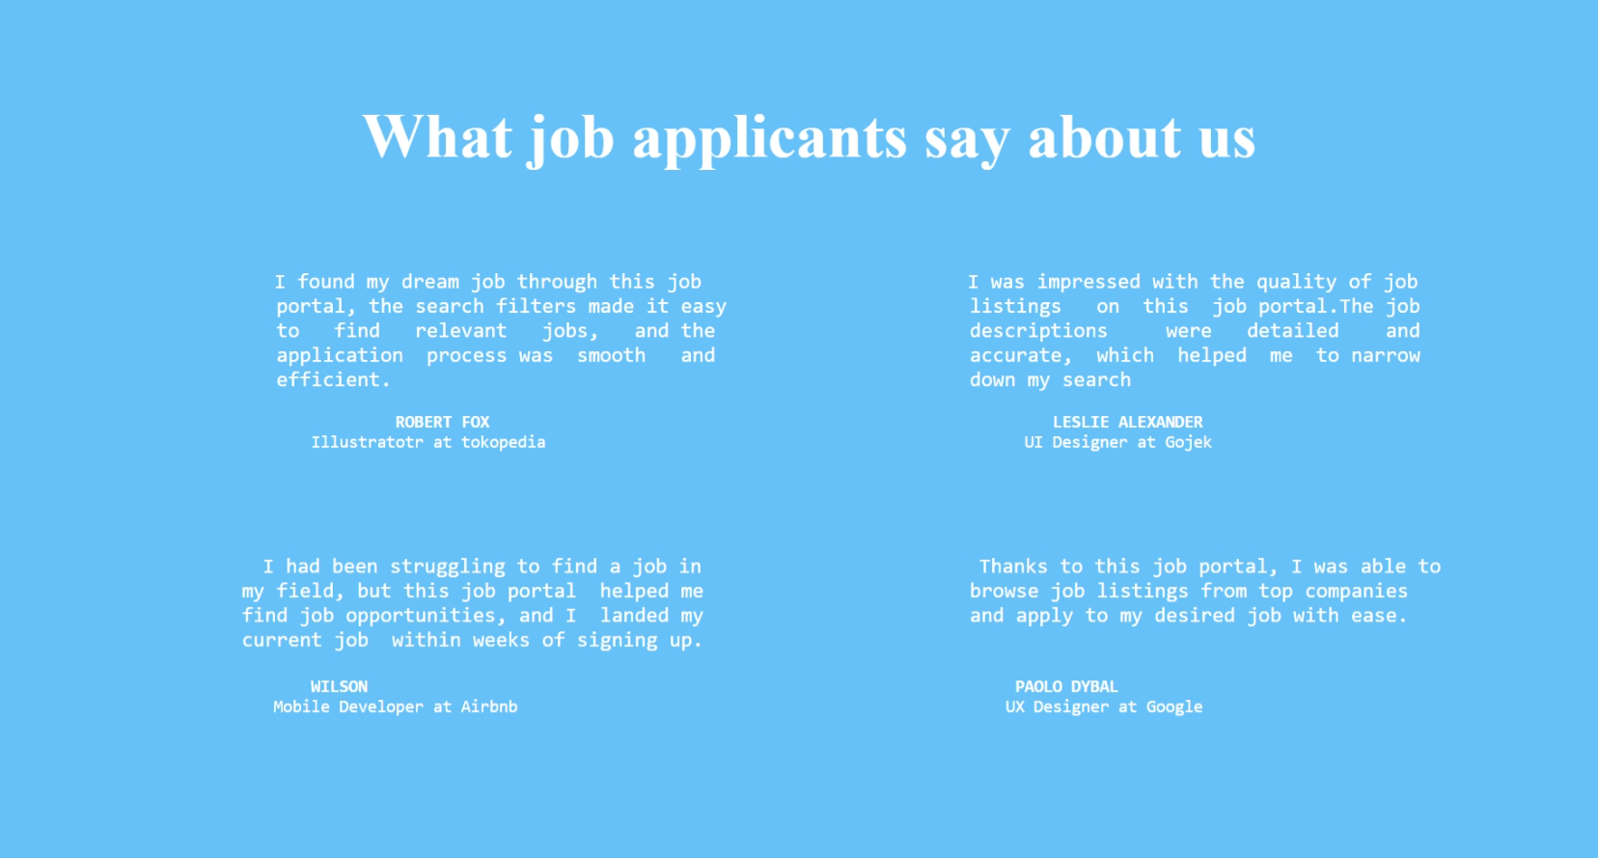

**Expected output:-**



During this workshop, This HTML code creates a simple webpage with a centered heading, two sections of text containing job applicants' feedback, and appropriate formatting using HTML elements and attributes. To complete this webpage, you should add a right side section of text using basic HTML elements and attributes.

**WORKSHOP3:**

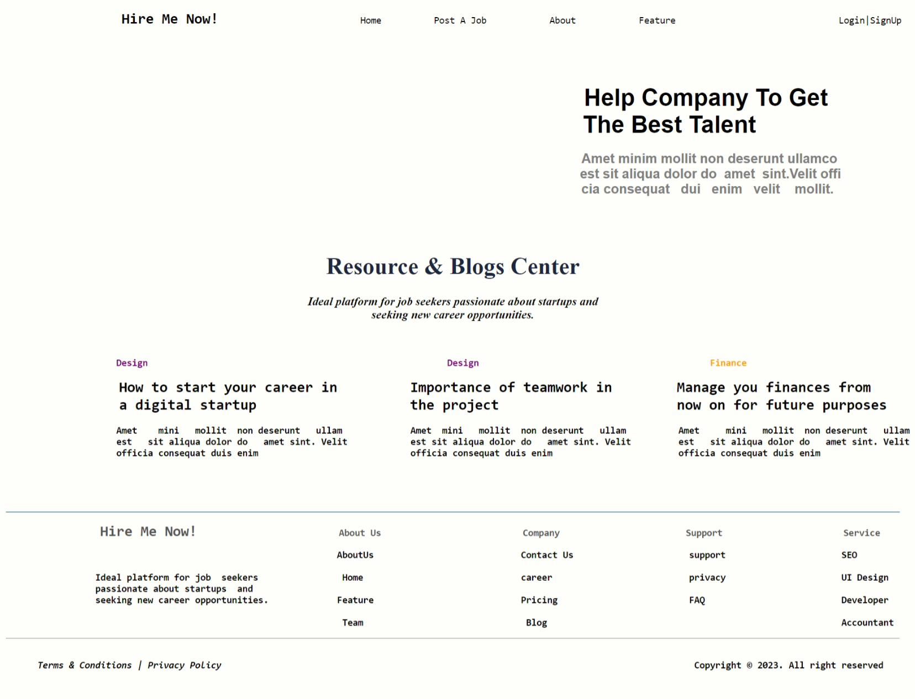

**Expected Output:**



In this workshop, you will learn how to create a basic webpage for a Job Portal System using HTML. You will understand the structure of an HTML document and utilize various HTML elements and attributes to format text, structure content, and create functional links within the webpage. To complete this webpage, you should add a header section using basic HTML elements and attributes.

**WORKSHOP4:**

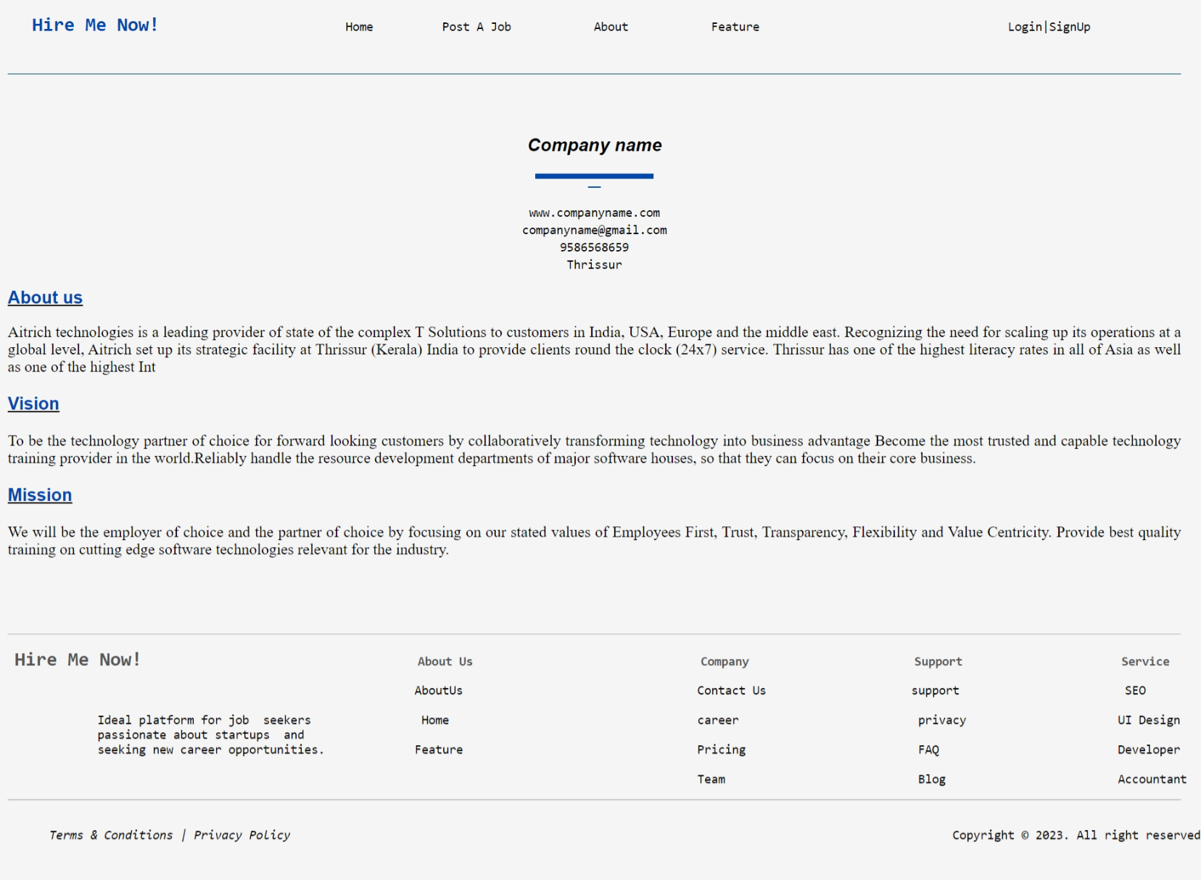

**Expected Output:**

In this workshop, you will learn how to create a basic webpage for a Job Portal System using HTML. You will understand the structure of an HTML document and utilize various HTML elements and attributes to format text ( including setting text size, color, font), structure content, and create functional links within the webpage. To complete this webpage, you should add a header section using basic HTML elements and attributes.

**WORKSHOP5:**

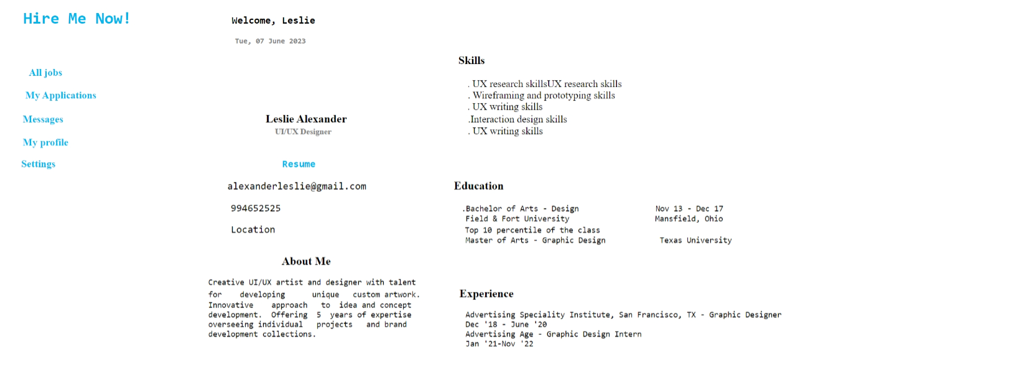

**Expected output:-**



In this workshop, you will learn how to create a basic webpage for a Job Portal System using HTML. You will understand the structure of an HTML document and utilize various HTML elements and attributes to format text ( including setting text size, color, font), structure content, and create functional links within the webpage. To complete this webpage, you should add a header section using basic HTML elements and attributes.